**Muhammad Tanzil-ur-Rehman**

**BCS211037**

**Section 01**

**Lab 9**

**Walkthrough Task**

.model small

.data

.stack 10h

.code

mov ax,1

mov bx,2

push ax

push bx

pop ax

pop bx

mov dx,ax

add dx,48

mov ah,02

int 21h

mov dx,bx

add dx,48

mov ah,02

int 21h

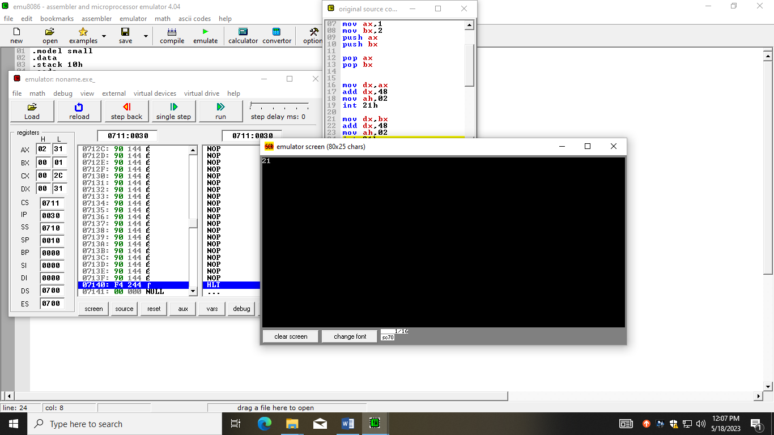

**Task 01**

.model small

.data

arr dw 0,1,2,3,4,5,6,7,8,9

ab db 0ah,0dh,"Reverse$",0ah,0dh

.stack 10h

.code

mov ax,@data

mov ds,ax

mov ax,[arr]

mov cl,10

mov si,0

l1:

push ax

mov dx,ax

add dx,48

mov ah,02

int 21h

inc si

inc si

mov ax,[arr+si]

loop l1

lea dx,ab

mov ah,09

int 21h

mov cl,10

mov si,0

l2:

pop ax

mov dx,ax

add dx,48

mov ah,02

int 21h

inc si

inc si

loop l2

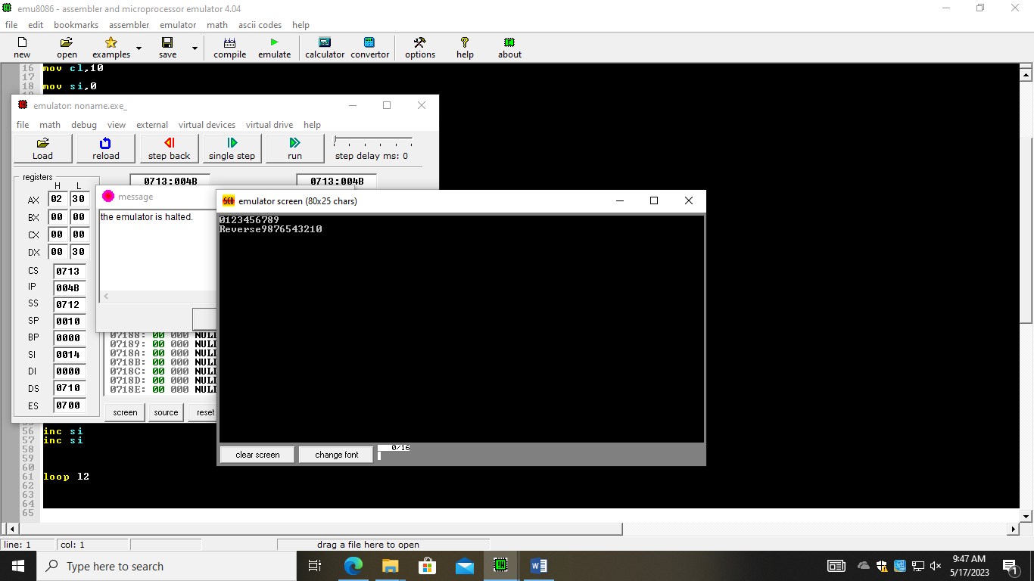

**Task 02**

.model small

.data

str1 db 0ah,0dh,"Enter 10 values in a array $"

str2 db ": $"

str3 db 0ah,0dh,"Even & less than 6 : $"

var1 dw ?

num1 dw ?

.stack 14h

.code

main proc

mov ax,@data

mov ds,ax

mov si,0

mov cx,10

l1:

lea dx,str1

mov ah,09

int 21h

lea dx,str2

mov ah,09

int 21h

mov ah,01

int 21h

mov ah,0

mov [num1+si],ax

inc si

inc si

loop l1

mov cx,10

mov si,0

mov bl,2

mov ax,0

l2:

mov ax,[num1+si]

div bl

cmp ah,0

je even

jmp odd

even:

mov ax,[num1+si]

cmp ax,36h

jle P

jmp odd

P:

push ax

inc var1

odd:

inc si

inc si

loop l2

mov cx,var1

mov si,0

mov ax,0

l3:

pop ax

mov [num1+si],ax

inc si

inc si

loop l3

mov cx,var1

mov si,0

mov ax,0

l4:

lea dx,str3

mov ah,09

int 21h

mov ax,0

mov ax,[num1+si]

mov dx,ax

mov ah,02

int 21h

inc si

inc si

loop l4

end main

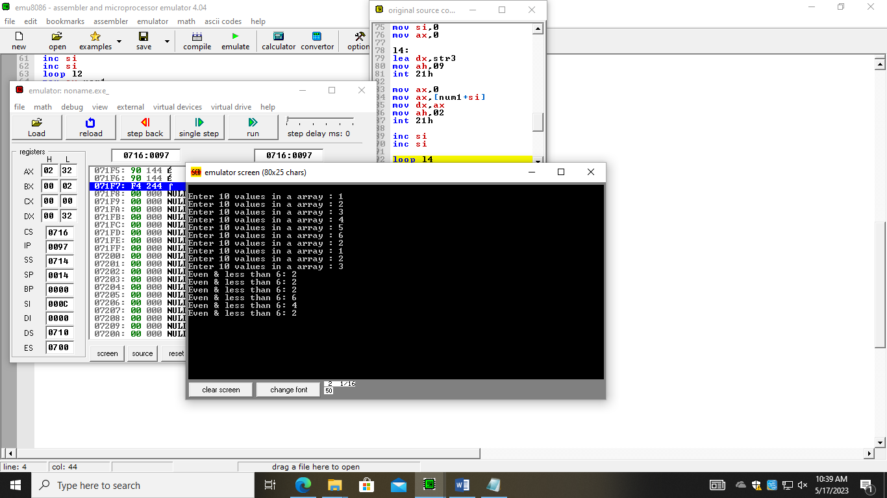

**Task 03**

.model small

.data

str db "Enter the values $"

str1 db 0ah,0dh,"Printing the values present in the string $"

.stack 10h

.code

mov ax,@data

mov ds,ax

lea dx,str

mov ah,09

int 21h

mov cl,10

l2:

mov ah,01

int 21h

push ax

loop l2:

lea dx,str1

mov ah,09

int 21h

mov cl,10

l1:

pop ax

mov dx,ax

;add dx,48

mov ah,02

int 21h

loop l1:

s